Label Creation for APS RSS Tags
(for 4” by 6” tags of yellow design)
For a small number of tags, the word template found here can be used.

For creation of a large number of tags, the Avery label maker software can be used. The instructions are listed below.
Creation of Tag Data List
- Open APS RSS tag label data template
- At minimum, input data in columns for Tag ID (the bolded part of an RSS label) and Tag Name (the italic part of an RSS label). If there is a QR code to the component in CDB, the url for the entry can be entered in the CDB QR URL column (otherwise, leave this blank).
NOTES: No formatting (font, size, bold, etc.) is necessary for this data entry. Create one entry per tag required. If a component needs multiple tags, repeat the lines of data for the number of tags needed. Do not use multiple tabs to record data.
- Save excel sheet and rename appropriately.
NOTE: The Avery label making software will not recognize multiple extra rows at the beginning of the spreadsheet (extra row labels, blank rows, etc.) and inclusion will result in issues with tag creation. For best results at max, only include one label row before proceeding to data entry.
Creation of Tag Label pdf
- Go to https://www.avery.com/software/design-and-print/
- Click “Start Your Design”

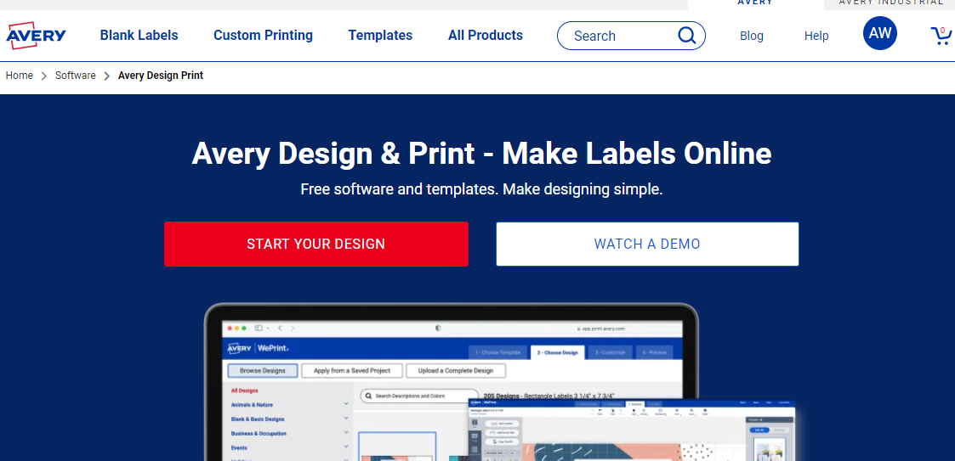
NOTE: You may need to register for a free account

- Select Template “5162”. This is the Avery Label style that fits the yellow tag blanks.
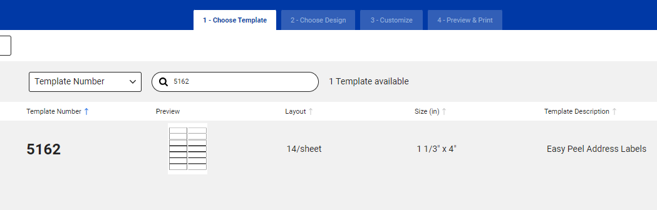
- Select the first blank design.

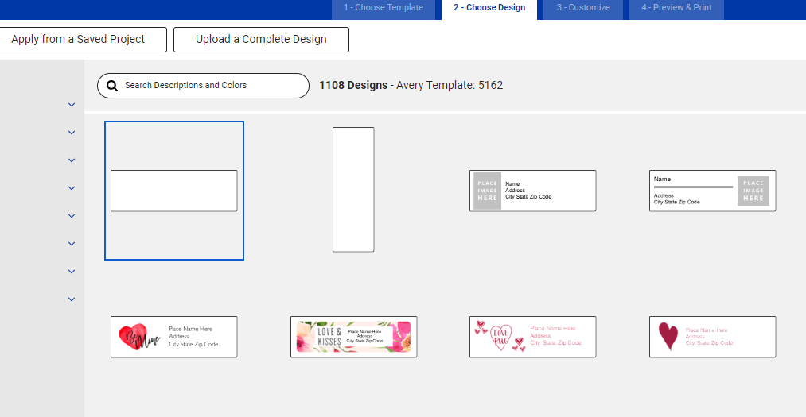

- If you have QR codes, continue to step 6. Otherwise, skip to step 11.
- To get the QR code on the tag, on the lefthand side of the screen, select “QR and Barcode” and then “Add QR/Barcode”
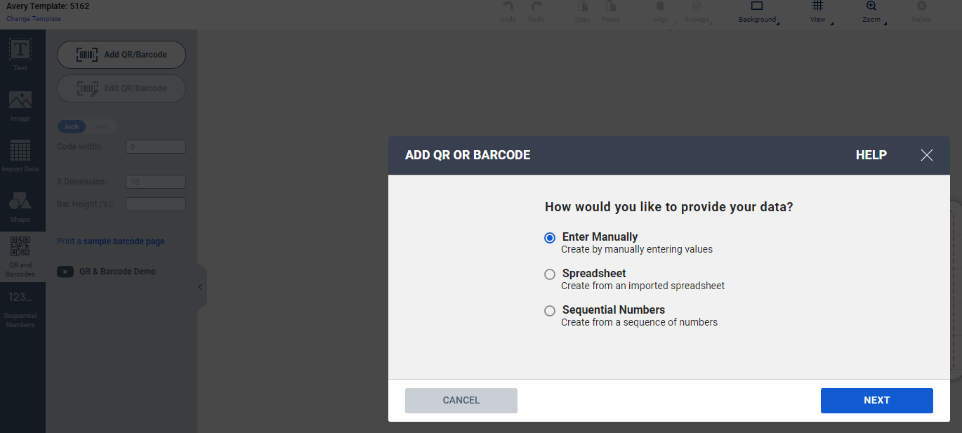
- Select the Spreadsheet option for importing data, select next, and select the spread sheet you want to use.

- After browsing for file to import, you will land on a “Choose Fields” page. De-select the row with column headings as well as the Tag ID and Tag Name columns and click next.
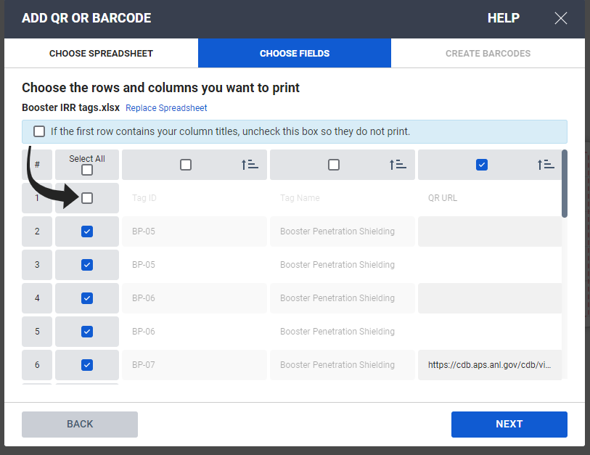
- In the Industry Standard Format Box, select “QRCode”. In the Code Type Field, select “URL”. In the website field, drag the QR URL box from Imported Data into the website field. Select Finish.
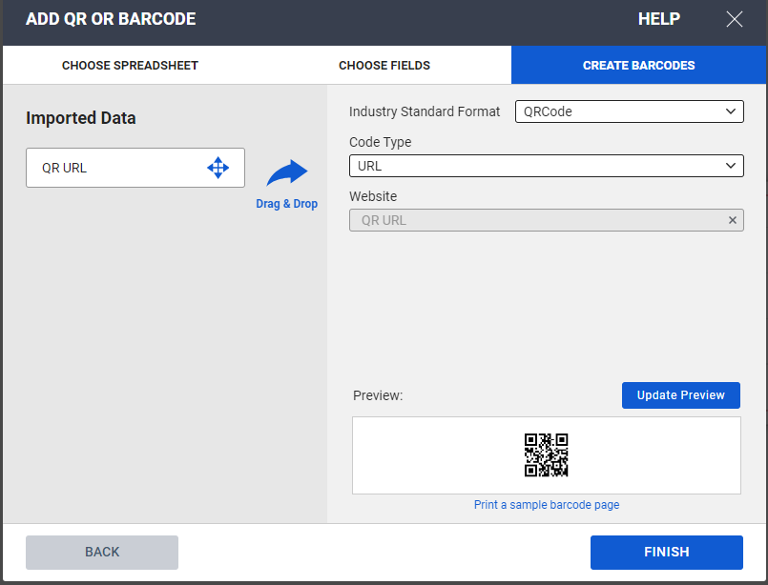
- If your first row of data does not have a QR code, the box will appear blank. That is ok. As the default for tag creation is to edit all tag labels at once, the QR box (blank or filled in) can be formatted in the displayed tag and all other tags will be updated. Before clicking off the QR code section, we will change the size and position the QR code box. On the left hadn side of the screen, in the Code Width field, change the width to 1 and hit enter. Drag the QR box to the left hand side of the label, within the dotted safety area lines (if you drag it outside of these, you will get an error message).
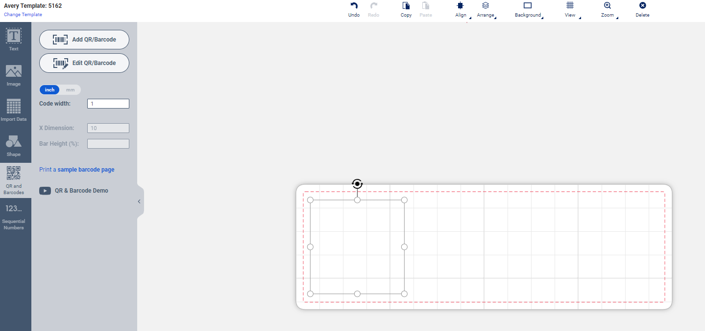

- To get text fields, on the lefthand side of the screen, select “Import Data” and then “Start Import/Merge”. If you have previously input QR code data, you will have the option to select “Choose Fields” instead.
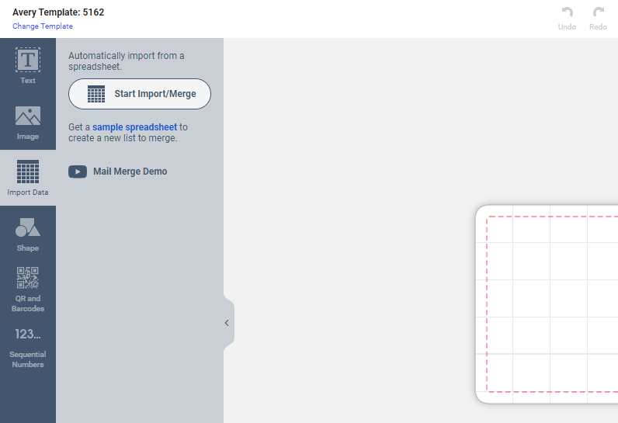
- After browsing for file to import, you will land on a “Choose Fields” page. De-select the row with column headings and click next. Make sure the Tag ID and Tag Name columns are selected.
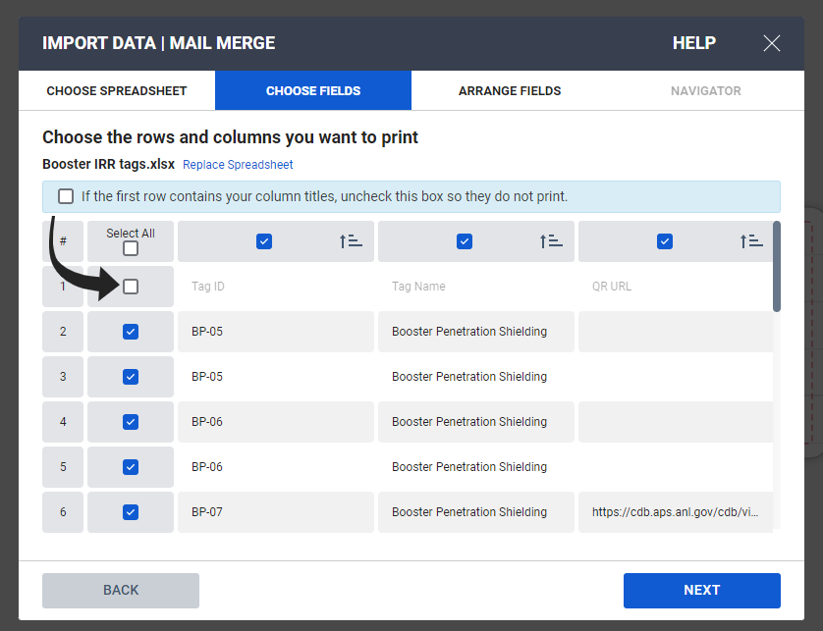

- Add the Imported Data Fields Tag ID and Tag Name to the white box by dragging or double clicking the options. Select next, then finish. Note: You do not need to select the QR URL field.
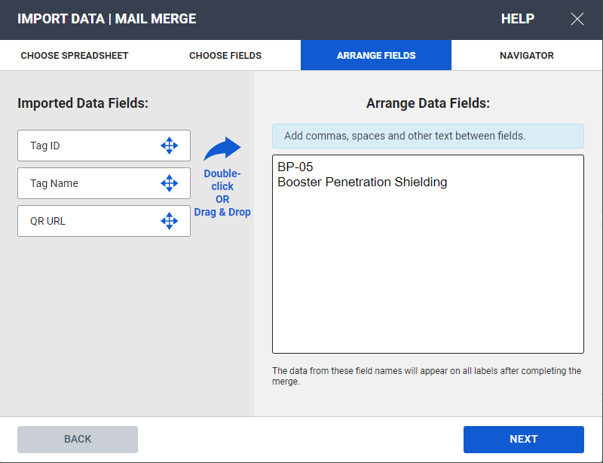

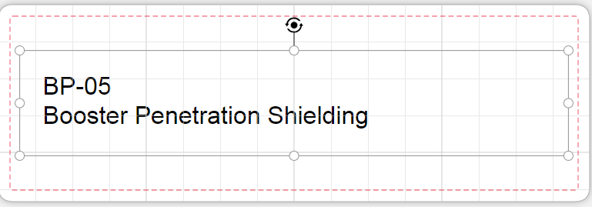
- The selected fields will appear in one box together. For better control of formatting and adjusting the tag, we will input the Tag ID and the Tag Name in separate boxes. To do this, deleted the box that was auto-generated.

On the left hand side of the page, select the Import Data tab. Drag the Tag ID box into the label field. Repeat for the Tag name box.
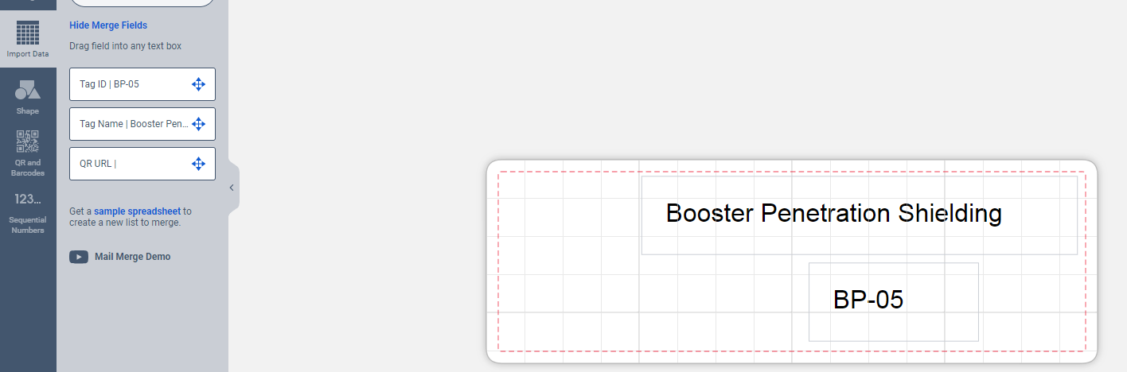
- Format the information. On the left hand side of the screen, select the Text option. Select the text box on the label that you want to adjust. Note: because the default of the software is to Edit all Tags at once, any formatting changes made for one label will show up on all of them. Formatting used is:
  - For Tag ID: Font-Verdana, Size-24, Bold text, Centered Alignment
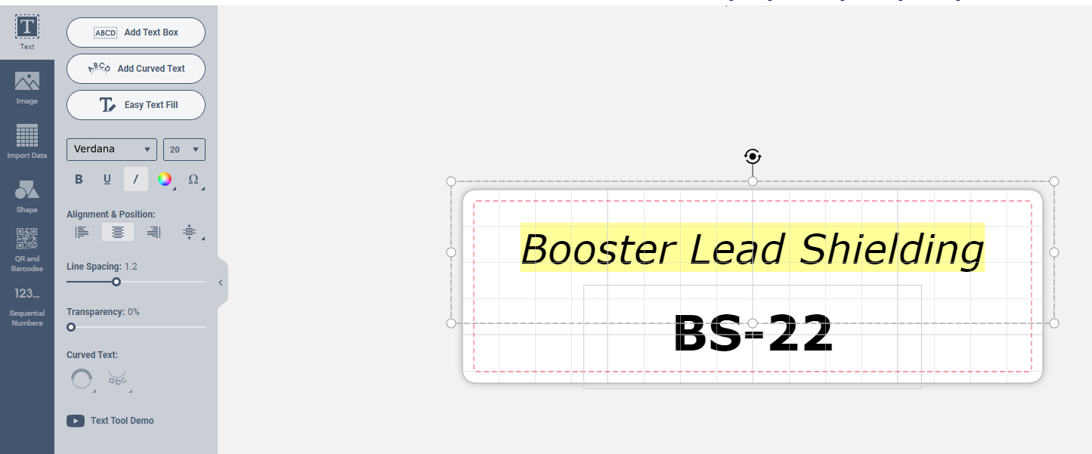
  - For Tag Name: Font-Verdana, Size 20, Italic Text, Centered Alignment

- Adjust the fields to fit. This is a bit fiddly, but adjust the boxes to fit the whole tag name and ID on the label. This may include the need to shrink or enlarge the field box the text is in, move it around, adjust fonts smaller, change spacing or centering of long text, etc. The most important part is to remain inside the printable boundary (dotted lines) and for labels including QR code, retaining the 1” sizing and left side placement.
- Check alignment of tags by flipping though the Navigator section on the righthand side of the page. Select any labels that are unreadable or have wonky formatting.
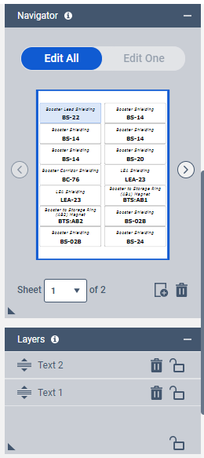
- If there are any labels with formatting that needs to be changed individually, select the label and select the edit one option. This will allow you to change the formatting of one tag at a time.
- When all labels look good, select the Preview and Print selection at the top of the page and select the GET PDF to PRINT button on the right hand side of the page. Save the PDF appropriately. You can also save the project with the formatting by using the save feature at the top of the page.
- Print labels using generated PDF. Apply printed labels to yellow tag blanks
NOTE: Make sure you grab the correct tag blank for the area (FE and beamlines, use the 2-0101 tag, Accelerator use the 2-9424 tag).
